When you run a photodiode test you should make sure each two consecutive events have strong color contrasts, which will cause the oscilloscope output to alternate:

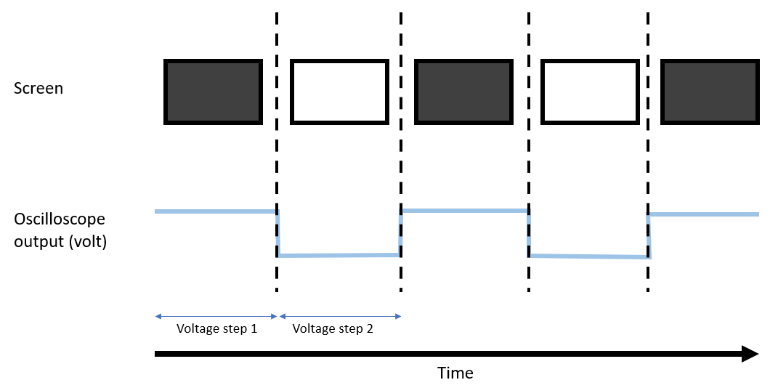

"photodiodeTest.m" measures the duration of each voltage step and compares it to the timing recorded by Matlab.

The Matlab timing is calculated as follows:

$$duration_{event_{i}}=timestamp_{event_{i+1}}-timestamp_{event_{i}}$$